**Individual Weekly Report**

**Name: Simone Kang**

**Team:** AIM Portal

**Date:** 2/10/2025

| **Current Status** |
| --- |

1. What did you **personally** work on this past week?

| **Task** | **Status** | **Time Spent** |
| --- | --- | --- |
| Group Reference Search, 10 Sources | Done | 1hr |
| Capstone Report Implementation schedule & Budget | Done | 1.5hrs |
| Tech Stack Selection | Done | <30min |
| Individual Reference Deep Dive | Done | 1hr |
| Basic codebase & deployment setup | Done | 2hrs |

Include **screenshots/graphics** to illustrate what you did this past week: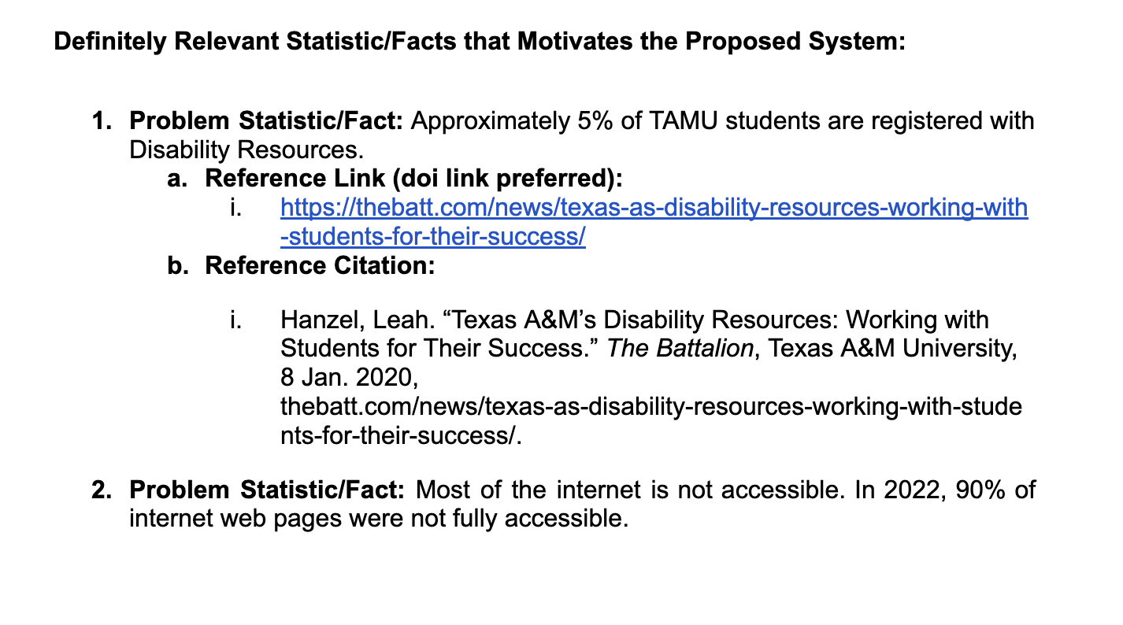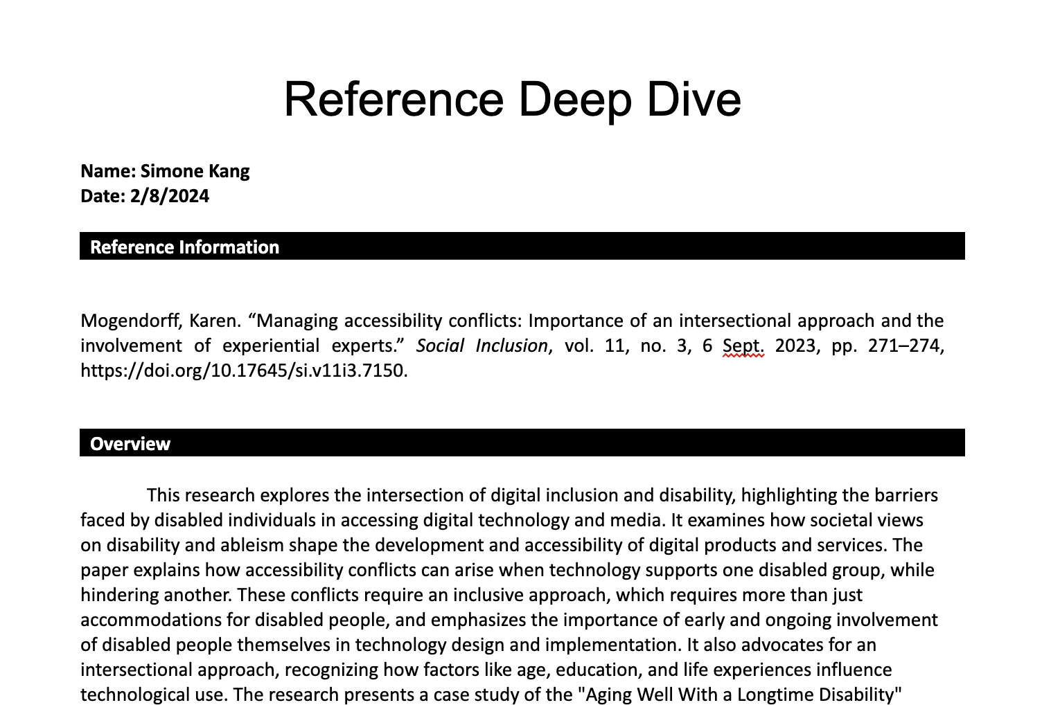

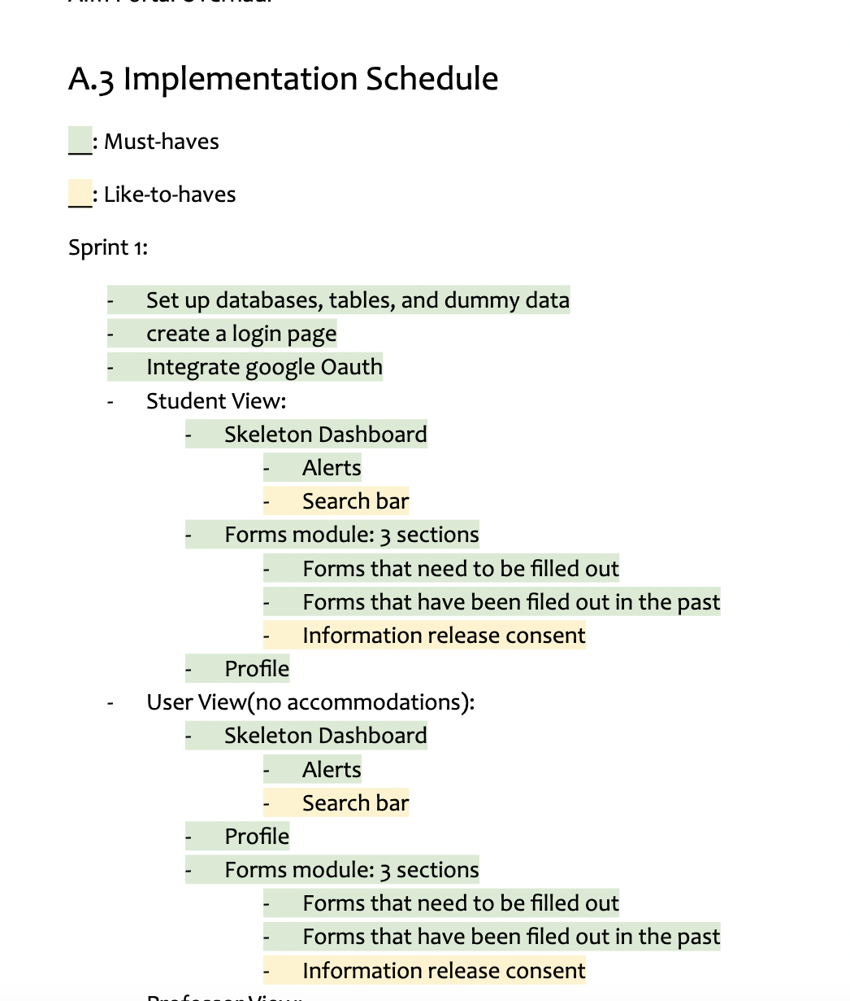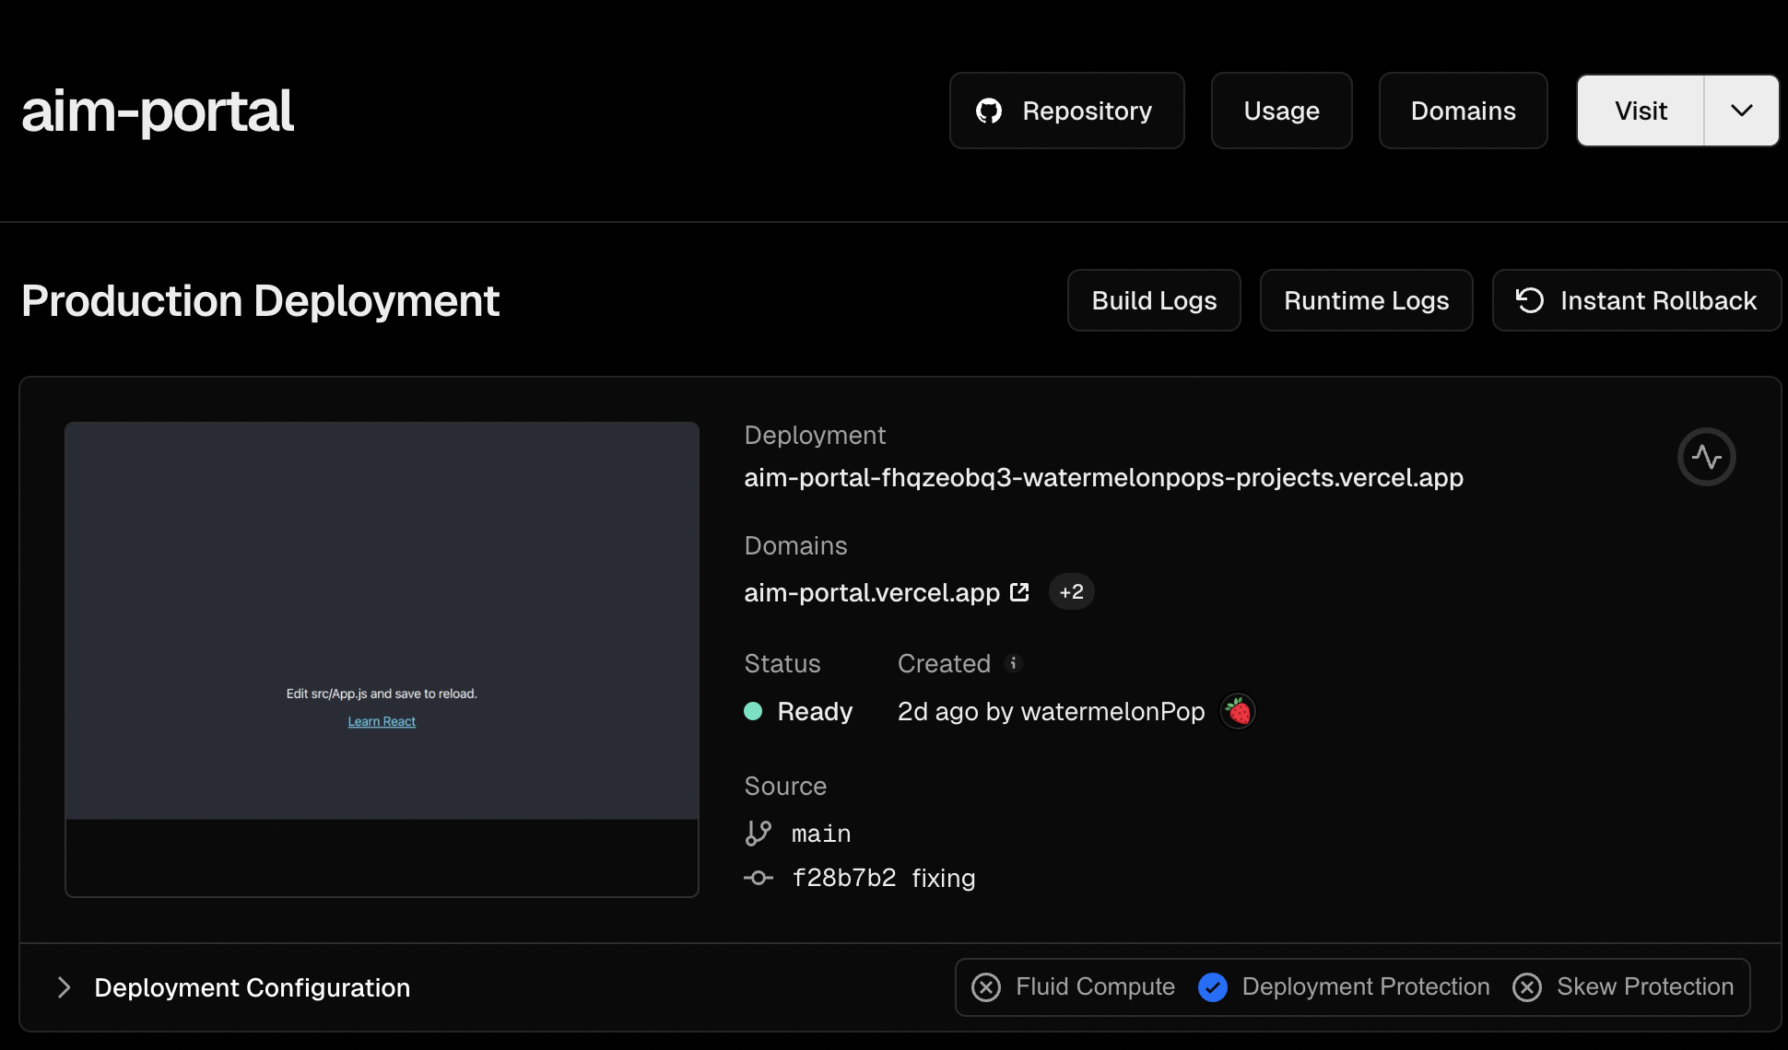

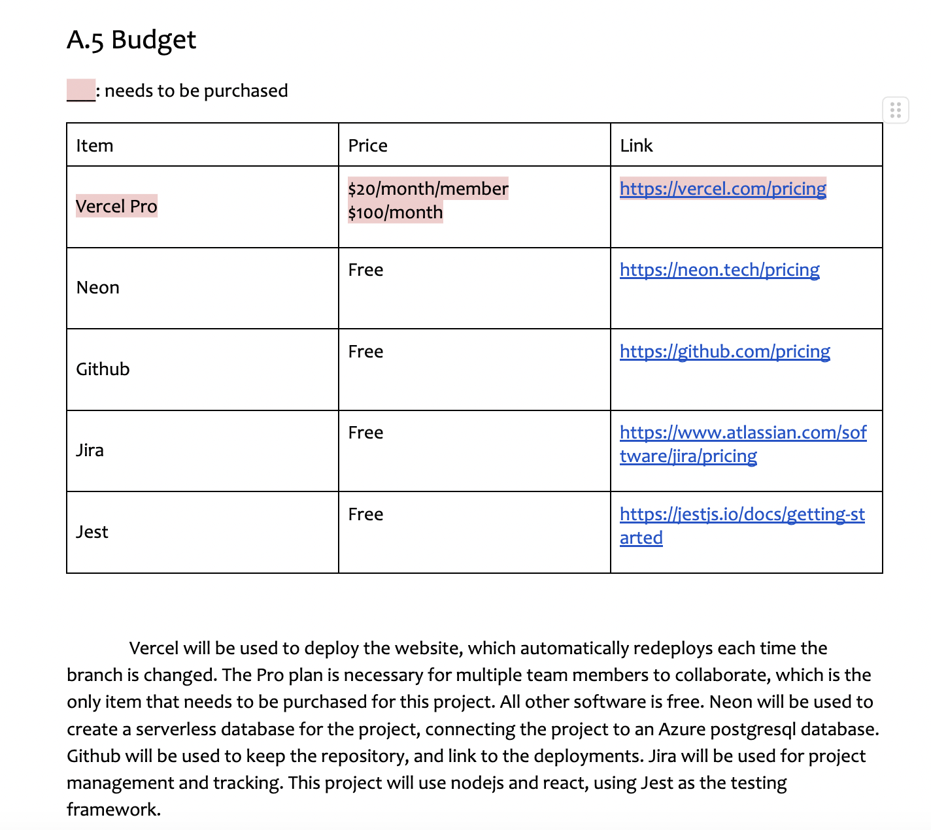

1. What problems did you run into? What is your plan for them?

No problems.

1. What is the current overall project status from your perspective?

We’ve set up a great foundation so far, and once we have more information from our sponsor, I feel that we’ll be on track to deliver a great first iteration.

1. How is your team functioning from your perspective?

Very well, we’re communicating frequently and effectively, and we’re all pitching in to make sure we’re getting assignments done.

1. What new ideas did you have or skills did you develop this week?

Learned about serverless databases via neon, very useful for our project.

1. Who was your most awesome team member this week and why?

I was, I set up the hosting, deployment and basic codebase.

| **Plans for Next Week** |
| --- |

What are you going to work on this next week?

Software development artifacts report

Prepare for Github release 1 & status demo 1

Get portal walkthrough recording from sponsor and incorporate information into the schedule & design.

Sprint 1 tasks:

* Skeleton page
* Create login page & integrate google oauth
* Accessibility settings & integration